**THE DAY I WILL NEVER FORGET**

T

here are days that are easily forgotten, but there are also those days which can never be forgotten as they change your life forever. One such unforgettable day happened to me when I was seventeen years old. It`s been three years now, but I still remember every single thing that happened on that day, as if it was just yesterday.

*It was a bright, sunny Sunday morning. I woke up and had my breakfast. It was the New Year`s Eve and we had planned to go somewhere to celebrate the New Year. As my family and I were sitting and planning* the event in the living room, something kept pinging my brain, as if a signal, I was not comfortable.

As we were planning the celebration, I ignored the disturbance in my mind and concentrated on various other things being planned. It was decided that we will celebrate the New Year in a mall. So in the evening, we got ready and sat in the car. I was sitting close to my beloved brother. Unaware of the future, I felt scared. I was disturbed and was not feeling happy at all.

We walked into the overcrowded mall. There were numerous things to look forward to and soon I forgot about the weariness I was having. After an hour or two, I noticed the absence of my brother. I started yelling at my busy family who jumped when they heard my first yell. My family and I started to look for my brother. Tears filled my eyes when I searched the whole mall without a sign of my brother.

Announcements we made but I could not see my brother. When it was midnight, we went hopelessly to our home. A lot of search and enquiries made but we did not find him. Our family had lost a precious part of it. I get sad and depressed when I think that had I understood what my sixth sense was telling me, my brother would have been with me today.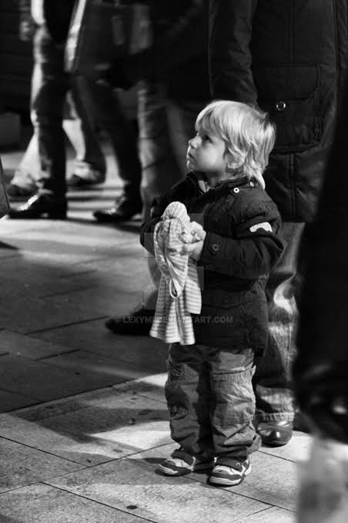

**Figure 1 Little boy looking lost**